PMT CONTROLLER

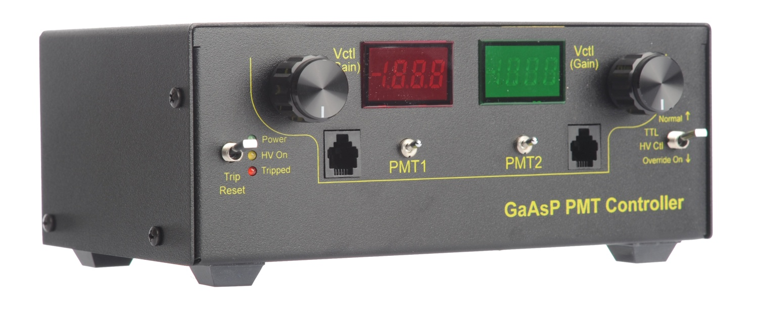

The PMT Controller provides two channels of control for GaAsP Photo Multiplier Tubes. The low –noise design uses static logic, linear power supplies, and an AC line filters. The control voltages are independently adjustable over their entire range via a multi-turn control, with the voltages displayed on the built-in meters. Each PMT can be switched on and off independently. A trip circuit is built in to detect high PMT currents. Trip level and duration can be independently set for each channel. A trip condition turns off both PMTs and can be reset via a front panel control. External control of high voltage and trip reset are also provided.



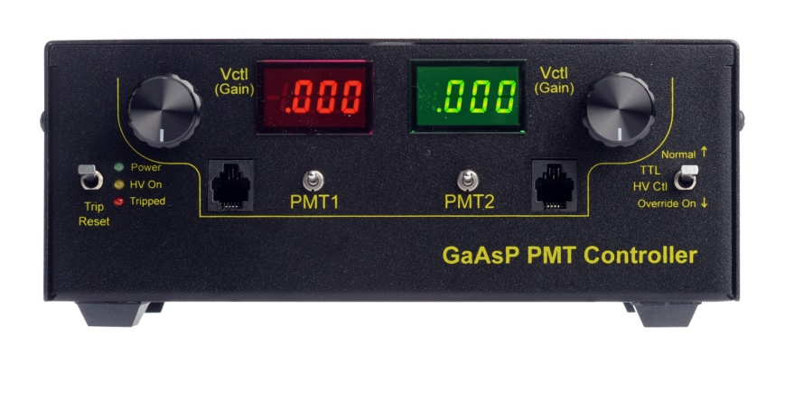

Front Panel

* Trip Reset: resets a tripped condition
* LEDs: Power On, High Voltage On, Tripped
* Vctrl: Control Voltage Setting (each channel)
* PMT connector (each channel) Pin out (left to right):
  + 15V Supply Out
  + Ground
  + Reference Voltage In
  + Control Voltage Out
* PMT1 (2): Enable control for each PMT
* HV Ctl: High Voltage control: Normal or Override (Overrides trip)

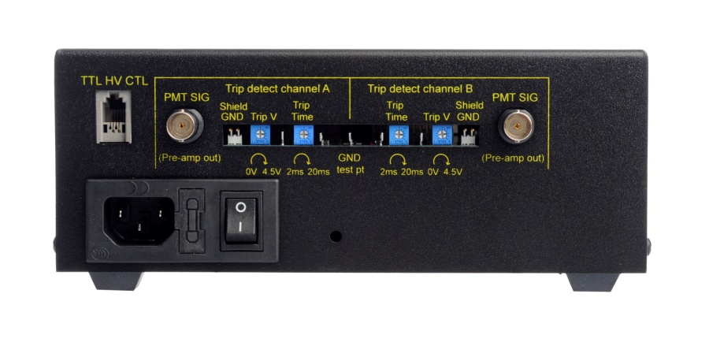

Rear Panel

* AC inlet, power switch, fuse
* TTL HV CTL: External HV and trip control. Active high TTL, isolated) Pin out (left to right):
  + TTL Trip Reset In
  + TTL High Voltage Control In
  + Isolated Ground
  + 5V supply in for isolator
* PMT SIG: PMT pre-amp input for trip detect (each channel)
* Shield GND: Jumper to connect PMT SIG shield to local ground (each channel)
* Trip V: Adjust the trip detect level (monitor via test pin) (each channel)
* Trip Time: Adjust how long trip level must be active before trip (monitor via test pin) (each channel)
* GND: test point ground reference